What is Food Quality Management System?

Food Safety relates to the security against presence of food-borne hazards in food at the point of consumption. Due to different vulnerabilities for food hazards getting added to food, in any of the food chain, requirement of adequate food safety controls through out food chain (FARM TO FORK), ISO 22000 specifies requirements for a Food Safety management system that combines interactive communication, system management, prerequisite program, and HACCP (Hazard Analysis & Critical Control Points) principles to ensure food safety along the food chain.

FOOD SAFETY – TOP PRIORITY



HAACP is just a method you follow in pursuit of food safety. The ISO standard's goal is to embed that methodology into your company's overall function, so your management practices are aligned to serve food safety in general and HAACP specifically. Everybody has a busy lifestyle and we need to consume healthy food to keep ourselves healthy. We need to make sure that the food we are eating is not harmful to us and it is free from harmful viruses, toxic bacteria, Parasites and chemicals. From the farmer’s farm to the consumer’s plate food safety plays a very important role in ensuring the quality of the food.

Where & how can Food Safety Management Systems be applied?

A **Food Safety Management Systems**(**FSMS**) can be applied to any organization, irrespective of size or industry sector. FSMS principle approach has following basic principles & strategies in place:

|  |  |
| --- | --- |
| Principles | Strategies |
| * See the source imageSanitize * Food Storage * Animation Art GIF by Ori ToorSafe Source * Implement HACCP * Training & Development * Quality Preparation * Prevent Cross Contamination * Time, Temperature & Humidity Consideration is Prime Concern | * Focus on Consumer Safety * HACCP Principles * Product & Process Food Quality * PDCA > Plan Do Check Act * Annex SL Mode l+ GMP Frame Work for FSMS Design * Prevention is Top Priority * Quality Storage, Distribution etc. * Farm to Fork Strategy |

What can make Food Safety Management Systems journey successful?

To implement & get maximum benefited from FSMS, there has to be ***baseline mindset principles***, in which every member of the organization (including Top Management) should believe in:

|  |  |
| --- | --- |
| Mind Set for FSMS | Benefits of FSMS |
| * The internal System implemented is to use the FSMS Principles in the right spirit; * Open mind to adopt culture for new understanding & learning concepts, technology, processes, etc.; * Complete Transparency in understanding, implementing changes, if need be, at appropriate time; * **Always believe that, what we know today is not enough and not the end**; * Always believe in and practice team work, commitment to improve and believe in that: * **Any System to be in such a manner that people depend on System, & not the other way round**”; * Ask self-question all the time - “Am I interpreting the requirements of FSMS Standard in current manner?; * Importance has to be given to documentation with Criteria inbuilt into it for internal transparency; * **Believe in building up Process KEDB (Known Error Data Base) – and update in disciplined manner and ensure that this is accessible to every one.** | * Clarity to Organization Governance to Control Organization & Business in a better Systematic and Consistent manner; * New Risk Based mechanism shall open your minds towards proactiveness which was existing in the form of Preventive Actions, which was totally neglected before. This Risk Approach gives an opportunity to all of make DFMEA and FMEA in more formal manner and reduce product / service failures in more effective manner; * Prevents Food Bourne diseases * Reduce wastages, mistakes & losses; * Improved control over food safety activities * customer, statutory and regulatory compliance * facilitated market growth * increased customer, stakeholder and consumer confidence in products * improved risk management & integration with other ISO management system |

What is Annexure L?

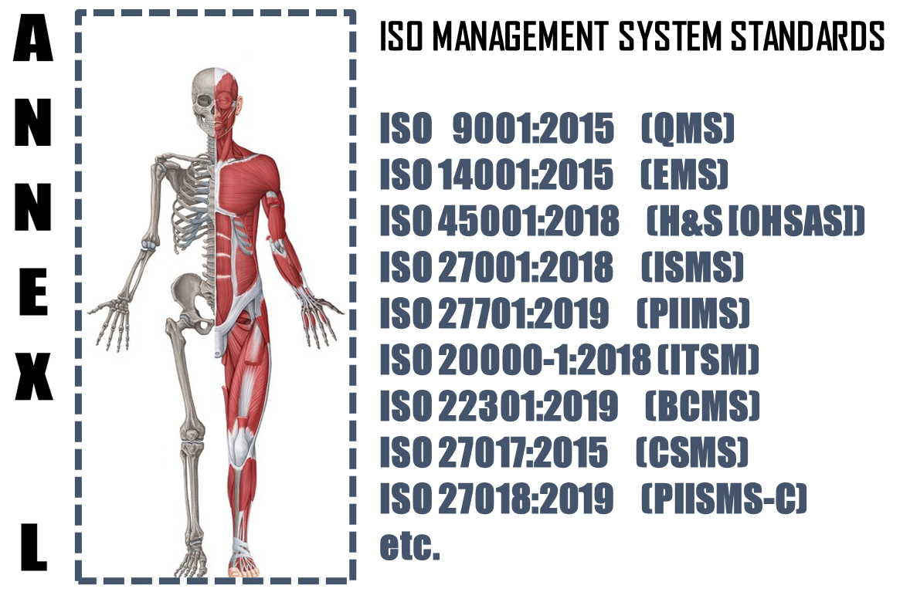

The **Annex L** (now renamed as Annex L in the 2019th edition from Annex SL) is a section of the ISO/IEC Directives part 1 that prescribes how ISO Management System Standard (MSS) standards should be written. The aim of Annex L is to enhance the consistency and alignment of MSS by providing a unifying and agreed-upon high level structure, identical core text and common terms and core definitions. The aim being that all ISO Type A MSS (and B where appropriate) are aligned and the compatibility of these standards is enhanced.

So in short we can say that Annex L is the Skeleton of ISO Management Systems and all standards are now aligned as per Annex L and all the common elements terms and definitions have also been standardized. This has been done to bring in Standard in the Structure, which was not the case in the past, though the intention was the same. So we can say, out of Intent and Content of MS, Content has undergone a change, in the form of Anne L.

What To Do in Implementing Food Quality Management System?

Based on the Scope and Context, following activities have to be performed in logical sequence. These guidelines given below are only basic milestones and a lot of activities may have to be streamlined as per the standard, based on Scope & Context.

|  |  |  |  |  |
| --- | --- | --- | --- | --- |
| **Step #** | **Requirement of FSMS** | **What needs to be done** | **In what way IRCBO can contribute** | **Tools Recommended** |
| 1 | Documentation | * Define Scope (Technical [Product/Services] and Territorial Scope (# Locations) where the FSMS is needed. The Org. Management decides the specific scope; * Defining the External & Interested Parties, their business relationship with Org. (in relevance to scope), Identification of critical processes, Information & Information classification); | IRCBO’s Qualified & Experienced consultants can help you in designing, defining, Implementing, monitoring and Improving the FSMS.  Note: Our contracts can also be associated after Certification for Maintenance of Management System through our digitized tool contributions – aim is to make any MS a plug and play for most effective Controls & Complying | IRCBO Tool Kit which includes all solutions for Implementation and backed up by IRCBO Designed Software in cloud for :   * Online training   (including  Induction for new employees, awareness & unlimited Internal Auditor Training & Qualification   * Online Internal Auditing Software |
| 2 | Implementation | * Defining, approving, sharing FSMS Policy; * Assigning Responsibilities and Authorities in more transparent manner; * Participating in Risk Mechanism and approving Residual Risk and Incident investigations; * Focusing on Increasing Competency, Considering Internal Audit Findings seriously for Timely Corrective Actions in effective manner; * Maintaining good discipline in demonstrating Leadership and aiming for improvements through Management Review platforms; |
| 3 | Periodical Review | * Performing Internal Audits * Performing Management Reviews |
| 4 | Continual Improvement | * Understanding the difference between Continuous Improvement & Continual Improvement and Implementing the same. |